Historical Feature Series: Second Edition
Focus: ‘Prospects 1977 - Implications for Youth Unemployment Today’ - Greg Baird
Winding the clock back to 1977 an editorial by J Pengley in the Prospects that highlights the concern in Australia at the time with unemployment, but particularly in the area of youth unemployment. Fast forward to February 2015 there is a similarly disturbing rate of youth unemployment today. In fact rates of youth unemployment have remained consistently disturbing since the GFC. The editor writes… I write at a time of increasing public awareness surrounding the plight of the unemployed school leavers. We, as a professional body of Career Advisers, have fought long and hard for the right to introduce vocational exploration models, through the venues of career education and work experience, in the school's overall curriculum… a new spectre has emerged, grimly reflected in the sad, faces of youngsters deprived of work. Unemployment, in the under 21 age group, is 4 to 5 times higher than the over 25 age group; and has risen from 15% of the total unemployed to approximately 45% since the mid-seventies.
Youth unemployment is clearly raised here as an imperative for action. It is a call to arms for action no less today than it was in 1977. Also in this edition, of Prospects, can be found the comments of the current Minster for Education, Mr.Eric Bedford, who is likewise concerned with the issue of youth unemployment stating the issue is… partly due to the economic situation and the grave dangers of unemployment facing school leavers. An enquiry by the Commonwealth Employment Service this year showed that 88% of jobs surveyed were for skilled people. From these figures, young people without a special skill face a far greater risk of unemployment. It is obvious that young people should make a decision on the special skills they should acquire before leaving school and this in turn throws a greater demand on the services of careers advisers. Our education system is also concerned· with the increasing need for careers guidance. In 1974 the Australian Education Council set up a national working party to enquire into the transition from work to employment. The report stated amongst its recommendations that: the relevance of vocational preparation to the total education process should be recognised and practised by all educational bodies and that reliable and current information about occupations, employment prospects and trends should be available to students, career personnel, parents and teachers.
With such an important part of this journal being concerned with youth unemployment it is evident that this was a rising concern at the time. In fact it can be seen clearly in the graph below that there was a significant rise in youth unemployment during the mid-70s. This is reflected in the overall unemployment on the lower line graph, but it appears that these indicators have an exponential effect on youth unemployment. Whilst it is clear there is a spike overall unemployment between 1983 and 1986, rising from 6.6% to 10.3% the greatest tragedy was the disenfranchisement felt by the young that were hitting the job market at that time with rates peaking at 18%.
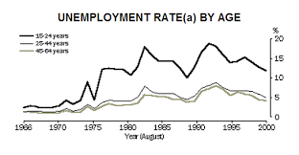
Whilst the youth unemployment today is not at this same level, and in fact is at a twelve month at 12.93%. The reality is that during this twelve month period it was still peaking at 14.43%. In the scheme of things even the September rate of 12.93 should still be unacceptable to us. The reality is that the rate is very similar to when Pengley wrote his urgent editorial in 1977. Have we come to accept that unemployed youths will always exist at such an alarming rate?
The Youth Unemployment Rate in Australia decreased to 12.93 percent in September from 13.68 percent in August of 2015. Youth Unemployment Rate in Australia averaged 13.50 percent from 1978 until 2015, reaching an all-time high of 20.22 percent in October of 1992. The reality is that the rate was just on average when Pengley wrote his urgent editorial in 1977. It seems we have come to accept that youth unemployment will always exist at such an alarming rate.
The good news is that in a media release from the Australian Bureau of Statistics Trend employment has increased by 260,500 since October 2014, contributing to an increased employment to population ratio over the year from 60.6 per cent to 61.1 per cent. The participation rate is also steady at 65%. The bad news is that statistically, if you are unemployed, you are almost three times more likely to be between the ages of 15 and 24 and this divide has been increasing since the GFC in 2008. In fact long-term unemployment has doubled since the GFC. Despite this alarming Statistic Australia has performed well in comparison with Europe and even the UK. See diagram below.
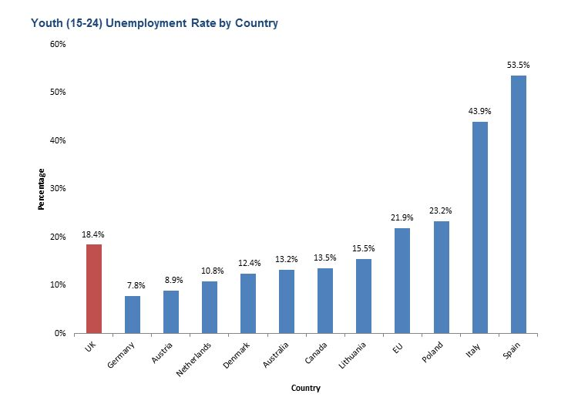

In an article by James Langford and Damien Riley, Feb 2015 ‘Youth unemployment : an international perspective,’ there is a focus on those countries that have performed better than the UK to isolate the measures that help to curtail youth unemployment and poor participation rates.
In this article Germany is singled out for having a strong vocational education component and strong funding to facilitate transitions into employment. The support is for 340 different occupations and these are aligned with market demands. This philosophy is very much part of the trait/factor school of thinking but clearly it has had economic and social benefits for Germany.
Interestingly Australia gets a mention here for the fact that those registered with a Job Services Australia provider for 12 months or more must participate in work experience activities including ‘Work for the Dole’, and ‘Green Corps.’ Participants have a degree of flexibility in the nature of the work experience they select, and are supported by Job Services Australia providers, and linked to participants’ ‘back to work’ Pathway Plan.

It seems systemic support measures for the unemployed, particularly youth unemployed is a vital measure to ensure increased participation rates moving forward and to avoid long-term unemployment issues. This is especially important as participation rates become increasingly affected by the retirement of baby boomers. In short, we have performed relatively well, since the GFC, but there are challenges ahead.

Whilst businessmen and politicians argue youth unemployment is high and rising because of high wages and economic factors, including the GFC, Rajaro Junankar’ (Honorary Professor – Industrial Relations Research Centre UNSW) recognises that: ‘…youth unemployment rates have been rising even though youth wages have been falling relative to adult wages.’
The only conclusion is that unemployment rates of young people have tended to rise in line with, but more rapidly than, adult unemployment rates. Junankar notes that: ‘During a downturn young people often end up on the receiving end of the “last-in-first-out” rule. They are almost certainly recent employees and if they are casual or part time, employers do not have to pay them redundancy payments.’ What follows from this is individuals will lack experience when the economy picks up and individuals may find they fall into the long-term unemployed list.

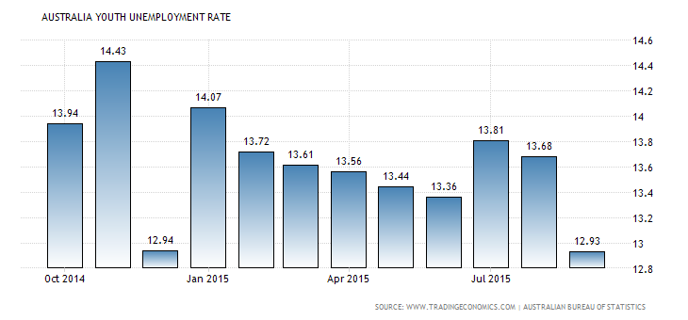
So if we know that Youth unemployment has risen since 2008 and in fact since for the thirty years prior to this, and British experts have recognised that government measures to support youth unemployment have worked in countries around the world to curb unemployment, what next?
The government has announced various measures for the 2015-16 budget Revision to specifically address youth unemployment. These include:
- $212.0 million over four years for intensive support services to be provided by a network of community-based organisations to early school leavers aged 15 to 21 years
- $13.5 million over four years to reinforce existing ‘earn or learn’ requirements, requiring early school leavers aged 15 to 21 years to study, actively look for work, or undertake a combination of the two and
- $105.7 million over five years for intensive support for vulnerable young job seekers who are at risk of long-term unemployment, including people with mental illness, young refugees and migrants and young parents.
The Budget also includes further, complementary measures:
- enabling access to the Youth Wage Subsidy for eligible job seekers aged 15 to 29 years after 6 months rather than after 12 months and
- $18.3 million over five years to expand work experience opportunities for people aged 18 years and over and provide them with a supplement to assist with the costs of participating in work experience.
Certainly these provide the funding for measures to deal with a burgeoning dilemma in Australia. Returning to the comments by the Minister for Education Mr. Bedford it is interesting that, in his address to the Careers Conference, he recognised the important role that face to face Careers Education and Advice played in educating and assisting students in their transitions into employment. In comparison to the UK this provides a secondary reason for their worse youth unemployment rates.

If the Minister for Education, Mr Bedford, was right then, and Australia’s rate is still unacceptable now, what more can be done? The government recognition and funding is a big part of this and will hopefully make a difference. More regulation with Careers Education could provide an additional improvement. At the moment, particularly in private schools, there is not the same emphasis on Careers. We need all schools including the private sector to participate in a shared vision for the future of our students. Perhaps this can only be achieved by greater regulation by education authorities and a common curriculum in all schools that considers a future focussed understanding of Australian industry. To Join the debate feel free to comment on my twitter account: @gregbairdca1

Bibliography

- www.fya.org.au/unlimitedpotential

Thomas, Dr. Mathew. ‘Workforce Participation Measures,’ http://www.aph.gov.au/About_Parliament/Parliamentary_Departments/Parliamentary_Library/pubs/rp/BudgetReview201516/Workforce

Riley, D. & Langford, J ‘Youth unemployment: an international perspective’ Public Sector Matters Blog, 20 February 2015
- Junankar, Raja ‘High youth unemployment can’t be blamed on wages’ April 16, 2015 The Conversation
- http://www.tradingeconomics.com/australia/youth-unemployment-rate
- http://pwc.blogs.com/publicsectormatters/2015/02/youth-unemployment-an-international-perspective.html

Boffey, Daniel. The Observer ‘Youth Unemployment Rate is the Worst for Twenty years,’

Australian Bureau of Statistics, http://www.abs.gov.au/ausstats/abs@.nsf/mf/6202.0

Australian Bureau of Statistics ‘Australia’s Trend employment increased by 260,500 over the year,’ 12th November 2015

Schneiders, Ben. ‘Long-term unemployment in Australia doubles since the global financial crisis,’ Sydney Morning Herald, Oct 11th 2014.

The Australian March 13th 2009, ‘Heeding the Lessons of the 1981 Recession,’

Pengley, J. Prospects, Journal of the NSW Careers Advisers Association, Term II 1977.

Pengley, J. Prospects, Journal of the NSW Careers Advisers Association, Term II 1977, editorial.
Pengley, J. Prospects, Journal of the NSW Careers Advisers Association, Term II 1977. P.2-3
Australian Bureau of Statistics ‘Australia’s Trend employment increased by 260,500 over the year,’ 12th November 2015
Riley, D. & Langford, J ‘Youth unemployment: an international perspective’ Public Sector Matters Blog, 20 February 2015
Thomas, Dr. Mathew. ‘Workforce Participation Measures,’ http://www.aph.gov.au/About_Parliament/Parliamentary_Departments/Parliamentary_Library/pubs/rp/BudgetReview201516/Workforce
Australian Bureau of Statistics ‘Australia’s Trend employment increased by 260,500 over the year,’ 12th November 2015

